WEEK 4 ASSIGNMENT
Predictive Modeling and Optimization in Logistics Systems
Delivery Time Forecasting Using Machine Learning
Student Name: Megha Chandra
Course / Program: B.Sc (Hons) Computer Science

1. Executive Summary
This report demonstrates a supervised machine-learning workflow to forecast logistics delivery time in hours. A hypothetical dataset of 1,000 shipments was generated with route, shipment, transport, warehouse, traffic, and weather features. Linear Regression, Decision Tree Regression, and Random Forest Regression were compared on a held-out test set. A five-fold cross-validation grid search tuned the Random Forest. The tuned model achieved test MAE 1.73 hours, RMSE 2.14 hours, and R-squared 0.787. All results are illustrative because the dataset is simulated.

2. Problem Definition
Logistics teams need reliable arrival-time estimates to set customer expectations, allocate vehicles and staff, and identify shipments that may require intervention. This is a regression problem: predict elapsed delivery time in hours from information available at dispatch.
Business question: Given shipment, route, transport, warehouse, traffic, and weather information, how long is a shipment likely to take? Target variable: delivery_time_hours. The model is intended as decision support, not a replacement for dispatcher judgement.

3. Dataset and Feature Description
The hypothetical dataset contains 1,000 shipment records. Numerical features are distance_km, package_weight_kg, number_of_stops, warehouse_load, and dispatch_hour. Categorical features are transport_mode, weather_condition, traffic_level, and region. The target is delivery_time_hours. shipment_id is an identifier and is not used as a predictor.
Feature | Type | Description
distance_km | Numeric | Estimated route distance in kilometres.
package_weight_kg | Numeric | Shipment weight.
number_of_stops | Numeric | Planned stops on the route.
warehouse_load | Numeric | Workload index from 0 to 1.
dispatch_hour | Numeric | Dispatch hour (24-hour clock).
transport_mode | Categorical | Road, Rail, Air, or Sea.
weather_condition | Categorical | Clear, Rain, or Storm.
traffic_level | Categorical | Low, Medium, or High.
region | Categorical | North, South, East, West, or Central.
delivery_time_hours | Target | Elapsed delivery time in hours.
A small number of missing values were deliberately introduced in package weight, warehouse load, and traffic level to demonstrate preprocessing. The dataset is synthetic and does not represent an actual logistics company.

4. Data Preparation
- Exclude shipment_id from model inputs and separate the target from predictors.
- Use an 80/20 train-test split with a fixed random seed for reproducibility.
- Impute numerical missing values with the median and categorical missing values with the most frequent category.
- Standardize numerical inputs and one-hot encode categorical inputs.
- Fit preprocessing inside a scikit-learn Pipeline so transformations are learned from training data only, reducing data leakage.
numeric_pipe = Pipeline([("imputer", SimpleImputer(strategy="median")),
("scale", StandardScaler())])
categorical_pipe = Pipeline([("imputer", SimpleImputer(strategy="most_frequent")),
("onehot", OneHotEncoder(handle_unknown="ignore"))])

5. Model Selection
Model | Rationale | Strengths and limitations
Linear Regression | Interpretable regression baseline. | Simple to explain; may underfit non-linear patterns.
Decision Tree | Captures thresholds and interactions. | Flexible and interpretable; may overfit.
Random Forest | Ensemble of decision trees. | Captures complex patterns and reduces single-tree instability; less transparent.
Random Forest was selected for tuning because delivery time may depend on interacting factors such as distance, transport mode, weather, traffic, and warehouse workload. Linear Regression provides a baseline and a single Decision Tree provides a non-linear comparison.

6. Model Training and Evaluation
Models were trained on 80% of records and evaluated on an unseen 20% test set. MAE is the average absolute prediction error in hours. RMSE gives greater weight to large errors. R-squared measures the proportion of target variation explained by the model and should be considered alongside MAE and RMSE.
Model | MAE (hours) | RMSE (hours) | R-squared
Linear Regression | 1.85 | 2.28 | 0.759
Decision Tree | 2.33 | 2.92 | 0.605
Random Forest | 1.76 | 2.16 | 0.784
Tuned Random Forest | 1.73 | 2.14 | 0.787
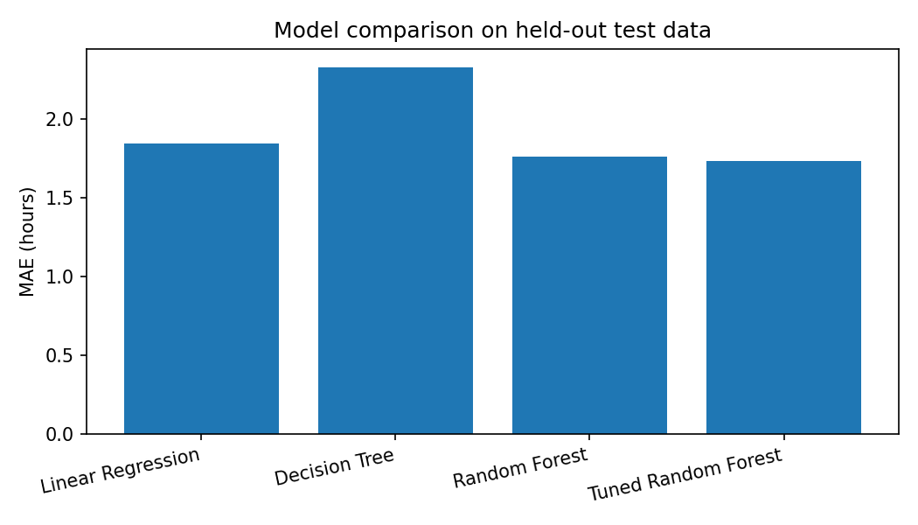
The tuned model's average absolute test error is 1.73 hours. Its RMSE is 2.14 hours and R-squared is 0.787. These values describe performance on this generated dataset only and should not be treated as real-world service levels.

7. Validation and Hyperparameter Tuning
A shuffled five-fold cross-validation strategy was used on the training data during GridSearchCV. Each fold is used once for validation while the other folds train the model. The search minimized MAE by testing maximum tree depth, minimum samples per leaf, and maximum features per split. The best cross-validation MAE was 1.80 hours. The test set remained separate for final evaluation.
param_grid = {"model__max_depth": [8, 12, None],
"model__min_samples_leaf": [2, 4, 6],
"model__max_features": ["sqrt", 0.8]}
search = GridSearchCV(pipeline, param_grid, cv=KFold(5, shuffle=True),
scoring="neg_mean_absolute_error")
search.fit(X_train, y_train)
best_model = search.best_estimator_
Selected parameters: {'model__max_depth': 12, 'model__max_features': 0.8, 'model__min_samples_leaf': 2}

8. Interpreting Model Insights
Model performance can help identify shipments at risk of delay and support operational prioritization. Random Forest feature importance may be reviewed to identify influential predictors, but importance is model-specific and does not establish causation. The team should verify patterns against real operational knowledge and segment-level error analysis.

9. Optimization Strategies
- Dynamic dispatch scheduling: use predicted duration and traffic conditions to avoid peak periods where feasible and within customer delivery windows.
- Route and stop sequencing: group nearby deliveries, reduce unnecessary stops, and test feasible route sequences subject to vehicle capacity, time windows, and driver-hour rules.
- Warehouse workload balancing: monitor workload and shift picking, packing, or loading resources to reduce dispatch bottlenecks.
- Exception management: flag shipments predicted to miss promised service windows for early intervention and customer communication.
- Transport-mode selection: compare feasible modes using predicted transit time, cost, capacity, reliability, and emissions rather than speed alone.
- Continuous monitoring: compare actual and predicted times, track MAE by region and mode, monitor late-delivery rates, and retrain when operating conditions change.

10. Illustrative What-if Scenario
The tuned model compared two hypothetical 220 km road shipments. Baseline: five stops, warehouse load 0.85, dispatch at 08:00, rain, and high traffic. Adjusted scenario: three stops, warehouse load 0.55, dispatch at 11:00, and medium traffic. Other fields remain the same.
Scenario | Predicted delivery time
Baseline | 16.12 hours
Adjusted | 13.63 hours
Difference | 2.49 hours
This is a model-based what-if illustration, not a guaranteed saving or causal experiment. Proposed changes must be checked for feasibility, customer time windows, labour rules, safety, cost, and service commitments.

11. Python Code: Training and Evaluation
X_train, X_test, y_train, y_test = train_test_split(
X, y, test_size=0.20, random_state=42)
model = Pipeline([("preprocess", preprocessor),
("model", RandomForestRegressor(n_estimators=160,
max_depth=12, min_samples_leaf=3, random_state=42))])
model.fit(X_train, y_train)
pred = model.predict(X_test)
mae = mean_absolute_error(y_test, pred)
rmse = mean_squared_error(y_test, pred) ** 0.5
r2 = r2_score(y_test, pred)
The accompanying Python script provides the full reproducible workflow, including preprocessing, comparison of three model families, and cross-validated hyperparameter tuning.

12. Limitations and Responsible Use
- The data are simulated; performance metrics demonstrate a workflow rather than real forecasting accuracy.
- Real logistics data may contain unobserved causes, measurement errors, seasonality, and changing operating patterns.
- Model performance may vary by region, transport mode, season, and unusual weather; report errors by segment before deployment.
- Prediction does not prove causation. A highly important feature is not automatically a controllable lever for reducing delivery time.
- Before deployment, validate on approved historical data, monitor drift, protect personal and commercial data, and retain human oversight.

13. Conclusion and Recommendations
This assignment demonstrates the full predictive workflow: defining a logistics problem, simulating and preparing data, comparing models, validating and tuning a model, evaluating test performance, and translating predictions into operational recommendations. The tuned Random Forest is a candidate model within this illustrative experiment. A practical next step is to replace simulated data with approved historical shipment records, validate accuracy across operational segments, and pilot prediction-led dispatch and exception-management workflows.

14. References
- Pedregosa, F. et al. (2011). Scikit-learn: Machine Learning in Python. Journal of Machine Learning Research, 12, 2825–2830.
- Scikit-learn documentation: Pipeline, ColumnTransformer, RandomForestRegressor, GridSearchCV, and model evaluation. https://scikit-learn.org/
- Pandas documentation: https://pandas.pydata.org/docs/
Reproducibility note: The companion CSV contains the simulated records. The Python script expects the CSV file in the same folder and requires pandas, numpy, and scikit-learn. Fixed random seeds are used in data generation and model splitting.

